**Practical 11**

**Exercise:-Design web application with the help of node js, express, body parser, express-session and mysql.**

**Program:**

**login.html**

<!DOCTYPE html>

<html lang="en">

<head>

<meta charset="UTF-8">

<meta name="viewport" content="width=device-width, initial-scale=1.0">

<link href="https://cdn.jsdelivr.net/npm/bootstrap@5.0.2/dist/css/bootstrap.min.css" rel="stylesheet" integrity="sha384-EVSTQN3/azprG1Anm3QDgpJLIm9Nao0Yz1ztcQTwFspd3yD65VohhpuuCOmLASjC" crossorigin="anonymous">

<script src="https://cdn.jsdelivr.net/npm/bootstrap@5.0.2/dist/js/bootstrap.bundle.min.js" integrity="sha384-MrcW6ZMFYlzcLA8Nl+NtUVF0sA7MsXsP1UyJoMp4YLEuNSfAP+JcXn/tWtIaxVXM" crossorigin="anonymous"></script>

<link rel="stylesheet" href="./login.css">

<title>Document</title>

</head>

<body>

<form action="/auth" method="post">

<section class="vh-100">

<div class="container-fluid h-custom">

<div class="row d-flex justify-content-center align-items-center h-100">

<div class="col-md-9 col-lg-6 col-xl-5">

<img src="https://mdbcdn.b-cdn.net/img/Photos/new-templates/bootstrap-login-form/draw2.webp"

class="img-fluid" alt="Sample image">

</div>

<div class="col-md-8 col-lg-6 col-xl-4 offset-xl-1">

<form>

<div class="d-flex flex-row align-items-center justify-content-center justify-content-lg-start">

<p class="lead fw-normal mb-0 me-3">Sign in with</p>

<button type="button" class="btn btn-primary btn-floating mx-1">

<i class="fab fa-facebook-f"></i>

</button>

<button type="button" class="btn btn-primary btn-floating mx-1">

<i class="fab fa-twitter"></i>

</button>

<button type="button" class="btn btn-primary btn-floating mx-1">

<i class="fab fa-linkedin-in"></i>

</button>

</div>

<div class="divider d-flex align-items-center my-4">

<p class="text-center fw-bold mx-3 mb-0">Or</p>

</div>

<!-- name input -->

<div class="form-outline mb-4">

<input type="text" name="username" id="form3Example3" class="form-control form-control-lg"

placeholder="Username" />

<label class="form-label" for="form3Example3">Username</label>

</div>

<!-- Password input -->

<div class="form-outline mb-3">

<input type="password" name="password" id="form3Example4" class="form-control form-control-lg"

placeholder="Enter password" />

<label class="form-label" for="form3Example4">Password</label>

</div>

<div class="d-flex justify-content-between align-items-center">

<!-- Checkbox -->

<div class="form-check mb-0">

<input class="form-check-input me-2" type="checkbox" value="" id="form2Example3" />

<label class="form-check-label" for="form2Example3">

Remember me

</label>

</div>

<a href="#!" class="text-body">Forgot password?</a>

</div>

<div class="text-center text-lg-start mt-4 pt-2">

<button type="submit" name="submit" class="btn btn-primary btn-lg"

style="padding-left: 2.5rem; padding-right: 2.5rem;">Login</button>

<p class="small fw-bold mt-2 pt-1 mb-0">Don't have an account? <a href="#!"

class="link-danger">Register</a></p>

</div>

</form>

</div>

</div>

</div>

<div

class="d-flex flex-column flex-md-row text-center text-md-start justify-content-between py-4 px-4 px-xl-5 bg-primary">

<!-- Copyright -->

<div class="text-white mb-3 mb-md-0">

Copyright © 2020. All rights reserved.

</div>

<!-- Copyright -->

<!-- Right -->

<div>

<a href="#!" class="text-white me-4">

<i class="fab fa-facebook-f"></i>

</a>

<a href="#!" class="text-white me-4">

<i class="fab fa-twitter"></i>

</a>

<a href="#!" class="text-white me-4">

<i class="fab fa-google"></i>

</a>

<a href="#!" class="text-white">

<i class="fab fa-linkedin-in"></i>

</a>

</div>

<!-- Right -->

</div>

</section>

</form>

</body>

</html>

**login.css**

.divider:after,

.divider:before {

content: "";

flex: 1;

height: 1px;

background: #eee;

}

.h-custom {

height: calc(100% - 73px);

}

@media (max-width: 450px) {

.h-custom {

height: 100%;

}

}

**Output:-**

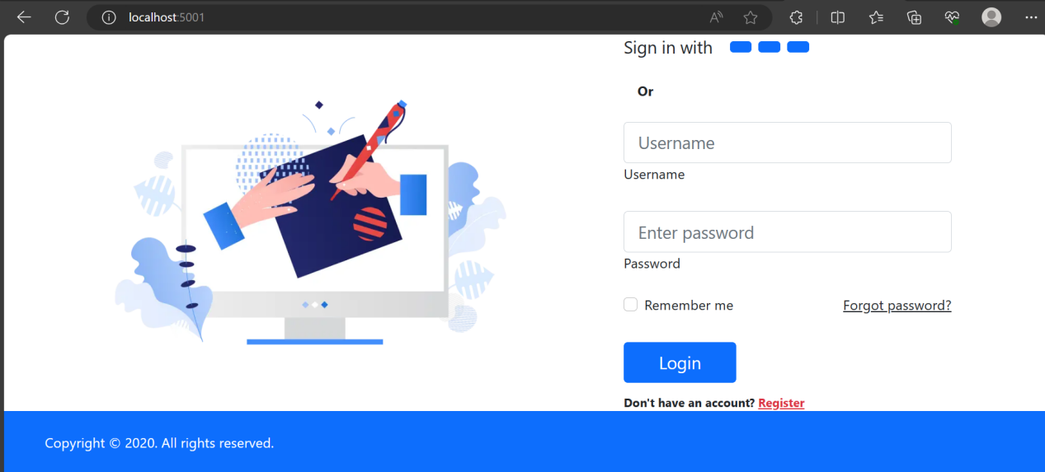

**register.html**

<!DOCTYPE html>

<html lang="en">

<head>

<meta charset="UTF-8">

<meta name="viewport" content="width=device-width, initial-scale=1.0">

<!-- <link rel="stylesheet" href="register.css"> -->

<link href="https://cdn.jsdelivr.net/npm/bootstrap@5.0.2/dist/css/bootstrap.min.css" rel="stylesheet" integrity="sha384-EVSTQN3/azprG1Anm3QDgpJLIm9Nao0Yz1ztcQTwFspd3yD65VohhpuuCOmLASjC" crossorigin="anonymous">

<script src="https://cdn.jsdelivr.net/npm/bootstrap@5.0.2/dist/js/bootstrap.bundle.min.js" integrity="sha384-MrcW6ZMFYlzcLA8Nl+NtUVF0sA7MsXsP1UyJoMp4YLEuNSfAP+JcXn/tWtIaxVXM" crossorigin="anonymous"></script>

<title>Document</title>

</head>

<body>

<form method="post" action="/formSubmit" >

<section class="h-100 h-custom" style="background-color: #8fc4b7;">

<div class="container py-5 h-100">

<div class="row d-flex justify-content-center align-items-center h-100">

<div class="col-lg-8 col-xl-6">

<div class="card rounded-3">

<img src="https://mdbootstrap.com/img/Photos/new-templates/bootstrap-registration/img3.webp" class="w-100" style="border-top-left-radius: .3rem; border-top-right-radius: .3rem;" alt="Sample photo">

<div class="card-body p-4 p-md-5">

<h3 class="mb-4 pb-2 pb-md-0 mb-md-5 px-md-2">Registration Info</h3>

<form class="px-md-2">

<div class="form-outline mb-4">

<label class="form-label" for="form3Example1q">Name</label>

<input type="text" name="name" id="form3Example1q" class="form-control" />

</div>

<div class="row">

<div class="col-md-6 mb-4">

<label for="exampleDatepicker1" class="form-label">Enter date</label>

<div class="form-outline datepicker">

<input type="text” name="date" class="form-control”

id="exampleDatepicker1" />

</div>

</div>

<div class="col-md-6 mb-4">

<label for="exampleDatepicker1" class="form-label">Select Gender</label><br>

<select class="select" name="gender">

<option value="1" disabled>Gender</option>

<option value="Female">Female</option>

<option value="Male">Male</option>

<option value="Other">Other</option>

</select>

</div>

</div>

<div class="mb-4">

<label for="exampleDatepicker1" class="form-label">Select Class</label><br>

<select class="select" name="cls">

<option value="1" disabled>Class</option>

<option value="Class1">Class 1</option>

<option value="Class2">Class 2</option>

<option value="Class3">Class 3</option>

</select>

</div>

<div class="row mb-4 pb-2 pb-md-0 mb-md-5">

<div class="col-md-6">

<div class="form-outline">

<label class="form-label" for="form3Example1w">Registration code</label>

<input type="text" name="regCode" id="form3Example1w" class="form-control" />

</div>

</div>

</div>

<button type="submit" class="btn btn-success btn-lg mb-1">Submit</button>

<a href="/logout" class="btn btn-success btn-lg mb-1">Logout</a>

</form>

</div>

</div>

</div>

</div>

</div>

</section>

</form>

</body>

</html>

**Output:-**

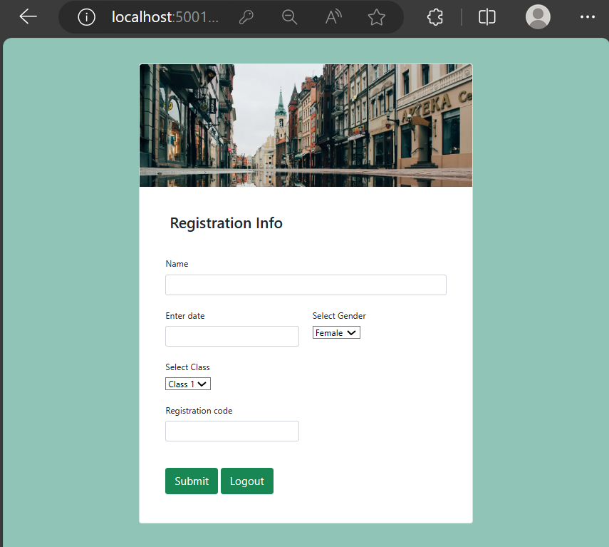

**dbConnection.js**

var mysql=require('mysql');

var con=mysql.createConnection({

host:'localhost',

user:'root',

password:'',

database:'studentInfo'

});

con.connect(function(err){

if(err){

throw err;

}

console.log('Connected!!!');

});

module.exports=con;

**run.js**

var express=require('express');

var mysql=require('mysql');

var db=require('./dbConnection');

var session=require('express-session');

var flash=require('express-flash');

var app=express();

var bp=require('body-parser');

// const {stringfy}=require('querystring');

// const { error } = require('console');

app.use(bp.json());

app.use(bp.urlencoded({extended:true}));

app.use(flash());

app.use(session({

secret:'your-strong-key',

resave:false,

saveUninitialized:true,

cookie:{ maxAge:70000 }

}));

app.get('/',function(req,res){

res.sendFile(__dirname + '/login.html');

});

app.post('/auth',function(req,res){

let username=req.body.username;

let password=req.body.password;

if(username && password){

db.query('SELECT * FROM login WHERE username = ? AND password = ?', [username, password],function(error, results){

if(error){

throw error;

}

if(results.length>0){

req.session.loggedin=true;

req.session.username=username;

res.redirect('/register');

}

else{

res.send('Incorrect UserName OR Password');

}

res.end();

});

}

else{

res.send('Please Enter UserName And Password!');

res.end();

}

});

app.get('/register',function(req,res){

if(req.session.loggedin){

res.sendFile(__dirname+'/register.html');

}else{

res.send('Please Login to View this page..');

}

});

app.post('/formSubmit',function(req,res){

if(req.session.loggedin){

var name=req.body.name;

var date=req.body.date;

var gender=req.body.gender;

var cls=req.body.cls;

var regCode=req.body.regCode;

var sql=`insert into register(name,date,gender,class,regCode) values("${name}", "${date}", "${gender}", "${cls}", "${regCode}")`;

db.query(sql,function(err,result){

if(err){

throw err;

}

console.log('record inserted');

req.flash('success','Data Added Successfully');

});

}

else{

res.send('Please Login to view this Page');

}

res.redirect('/register');

res.end();

});

app.get('/logout',function(req,res){

req.session.destroy((err)=>{

res.redirect('/');

});

});

app.listen(5001,()=>{

console.log("server is running")

});

**Output:-**

**Login Table-**

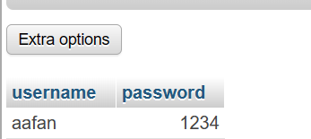

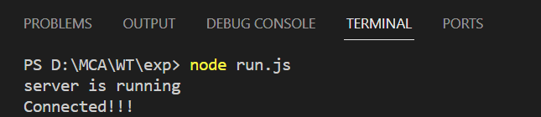

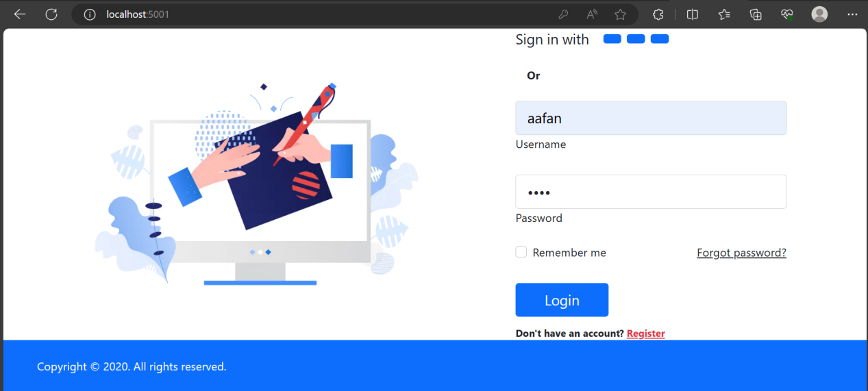

**Register Table:-**

